## 

## +Merchant

Scoping start date: 2023

Implementation Completed Date (Go live date): 2023

MSA Signature Date: 3/6/2024

GTM POC: Rebecca

ERP: QBO

Tax Integration: Other

### 

### Key people at Merchant

### Andrew Schlenger - Head of Product Strategy (BizOps)

* Jess Hubbard - Strategic Programs Manager

### Company summary

BrewBird manufactures a high-end coffee brewing machine and pods of locally roasted coffee beans. They sell or lease the machines to the office market (e.g. Meta offices) and then sell the pods on a recurring on-demand basis.

AM Notes

* Slightly different use case for Tabs as we are primarily supporting PO-based pod orders

### Billing model

* Brewer is either sold or leased
* Pods are sold on a recurring, on-demand basis via POs

### Contract Processing Steps

1. “Contracts” are POs from OrderTime (BB’s order management system) - BPO checks for new orders, pulls the PO, uploads to Tabs to process. We complete this flow in the early AM so BrewBird can get notified by 6am PT/9am ET of a new invoice ready to approve.
2. Please send comms to Chirag everyday once ordertime is checked. Comms should state if there were any ship docs from previous day, and if so how many. Also flag in case more than 1 contract is uploaded for the same customer.
3. Invoice # should match the Ship Doc Order #
   1. If duplicates exist, ping Chirag → CX

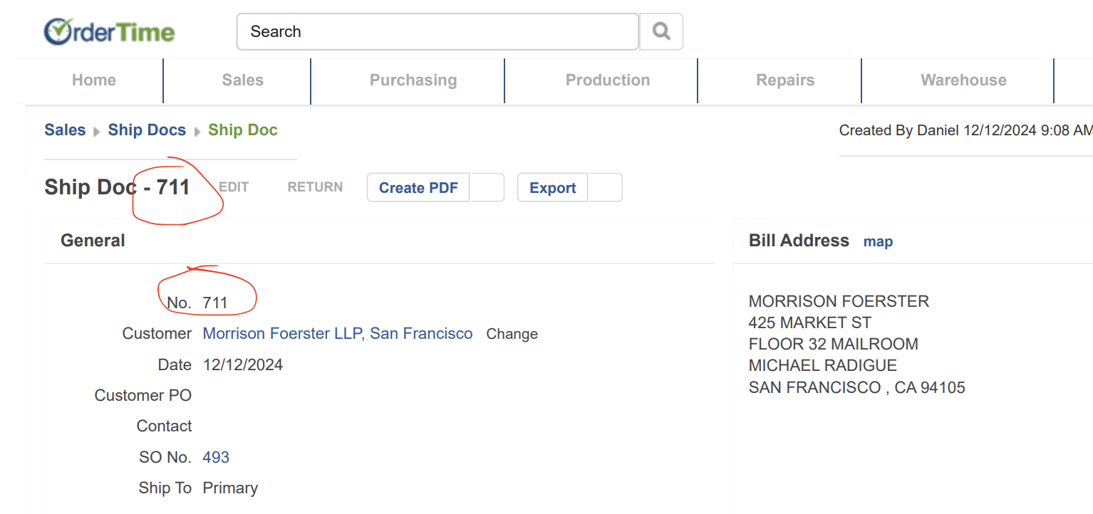

* 1. Invoice Number should be updated from *garage* not from the merchant app. (See Screenshot Below for proper place to update Invoice Number)

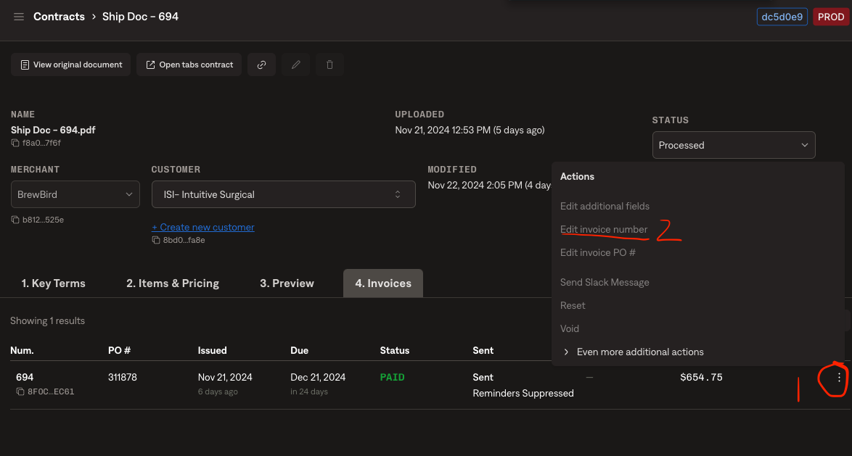

1. If OrderTime order includes ground shipping, please create a BT for ground shipping Integrated with “Shipping Item”
2. If OrderTime order includes “Brewbird Event” OR “Brewbird Event Staff” the integration item for that BT is “Services”
3. If OrderTime order includes "Brewbird Coffee Machine" use Integration Item "Brewers:Brewer Sales"
4. Please include all items from order time on the invoice, even if they do not have a dollar value associated with them. Example: 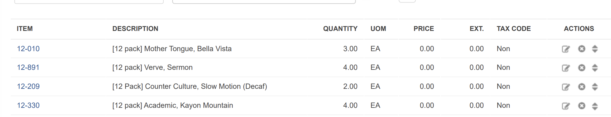  
   In the above screen shot - each of these would receive its own line item on the invoice.
5. If there is a “Customer PO” in order time, it **must** be added to the invoice in the “P.O. Number” field - if the “Customer PO” field is blank, it **must** be blank on the invoice.
   1. If there is any question at all about the accuracy of the “P.O Number” field, it is better to put the contract on hold and reach out to CX than to process incorrectly. Extremely sensitive merchant.
6. “P.O Number” should be updated at the *invoice* level from *garage*. Not at the customer level, not in the merchant app. (See Screenshot below for proper place to update “P.O. Number”

### 

1. No Credit Card BTs to be processed (Flag to Chirag → CX for questions)

### Events Processing (if necessary)

* POs essentially serve as our “events”

### Customer Information

* Two main customers so far, both serve Meta (at different offices): Snackwise & Canteen
* Snackwise pays via ACH and is slower to pay / more difficult to work with (they are being phased out potentially)
* Do Not Process: Customer Name: Brewbird HQ, Brewbird Eng, Brewbird Service

### Feature Requests

* Auto-approve invoices (e.g. without Jess needing to approve individually)
  + Will be good candidates for Slack approval too
* Customize payment method options by end-customer
* More customized dunning by end-customer
* Generally would like an even faster turnaround from order/PO → invoice

### Rewatch Calls